Bell ringer:

Part I What 2 things cause our seasons?

Part 2 What are the dates for:

Spring Equinox

Summer Solstice

Fall Equinox

Winter Solstice

Answers:

Part 1 the **tilt** of the earth’s axis and **revolution** around the sun.

Part 2 What are the dates for:

Spring Equinox March 21

Summer Solstice June 21

Fall Equinox Sept. 21

Winter Solstice Dec. 21

% error = difference between estimate and actual X 100

actual

do some examples. Include percent error in lab report due next week.

Wagner: <http://www.dragon.k12.pa.us/facstaff/HS/wagner_v/www/Movie%20on%202011-11-21%20at%2007.57.mov>

Students will create I movies that demonstrate what causes the 4 seasons in Lewisburg PA. Make a model of the Sun, and a styrofoam ball as the earth.

Movie should contain all of the following information:

What does the Earth Sun relationship look like for: (2 point2)

Spring Equinox

Summer Solstice

Fall Equinox

Winter Solstice

Movie should show earth’s tilted axis as we orbit the sun. (1 point)

Bell Ringer 2- When air heats up does it;

expand,

contract,

or stay the same?

Expand

Demo Coriolis effect with balloon and student assistant.

Discuss page 71

1. In your notebook, draw a large circle (softball size) to represent the Earth. **(Refer to page 71)**

Label the Equator (0 degrees latitude), label both 30 degrees, both 60 degrees, and both 90 degrees.

Draw and label the:

Polar Easterlies

Westerlies

Northeast Trade Winds

Southeast trade winds

Westerlies

Polar Easterlies

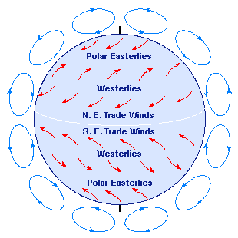

Historic Winds / immigration

Exit Bellringer: The Coriolis effect is due to:

a) variations in the amount of solar radiation reaching different locations.

b) seasonal changes in the levels of solar radiation at a given location.

c) The density of the oceans.

d) the Earth's orbit.

e) the Earth's rotation.

Answer: E Earth's rotation.